# Getting started: Javascript

This document defines the **recommended software** for the ["SoftwareTechnologies" course @ Software University](https://softuni.bg/courses/software-technologies). Here will be give some information about the programs we are going to use and how to install them.

# Javascript IDE/Editor

## Резултат с изображение за webstormWebStorm

WebStorm is one of the most (if not the most) popular **IDE** ‘s that support **Javascript**.

**Pros**:

* As any other IDE you have **intellisense** and **autocomplete** which boost your performance.
* It is made by JetBrains and is much **alike** any other of their **products** (e.g. **PhpStorm**, **IntelliJ**).
* **Initial** project **setup** is configured for most project (e.g. Node.js/Angular etc.)

**Cons**:

* Requires license for any non-trial use (trial is for 30 days).

Here you have the **download** link: [click](https://www.jetbrains.com/webstorm/download/#section=windows-version).

Installation is **straightforward**:

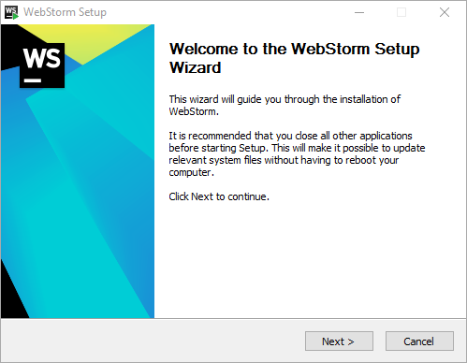After you have downloaded the installer, run it:

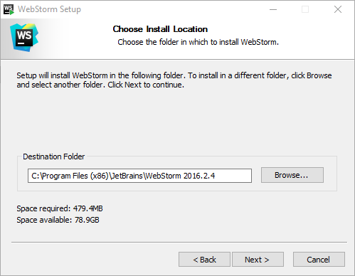

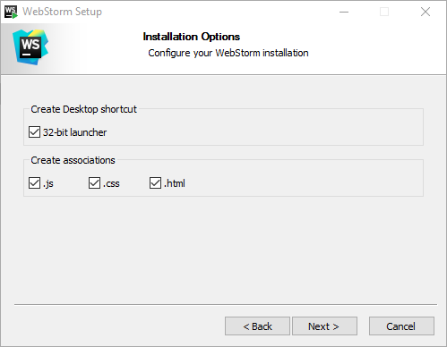Select installation path.

These ticks above are **optional**. What will they do is to set WebStorm as a default program when opening files with extensions “**.js**”, “**.html**” and “**.css**”. And also a desktop icon. ☺

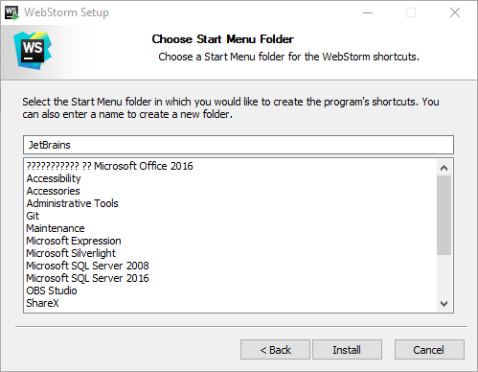

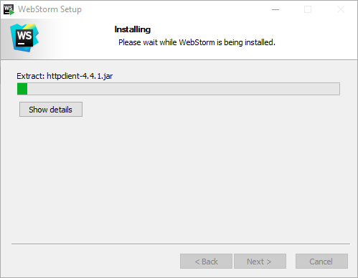

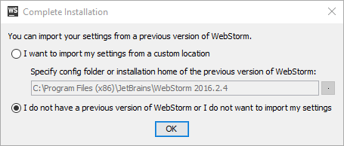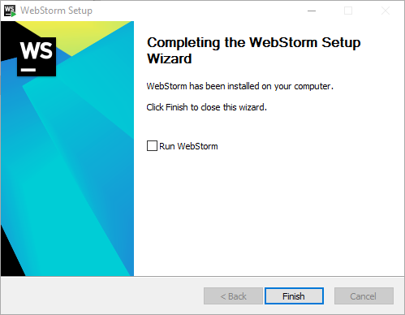Then you start the IDE and a window will pop up:

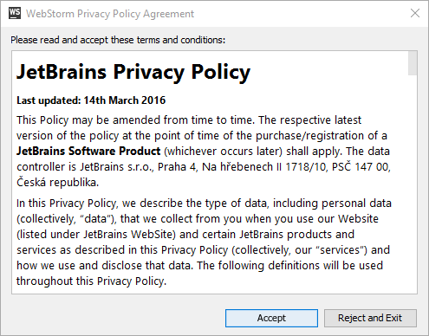If this is your **first time** installing **WebStorm** or you don't want to import any previous IDE settings just click **OK**.

Click **Accept** and move on.

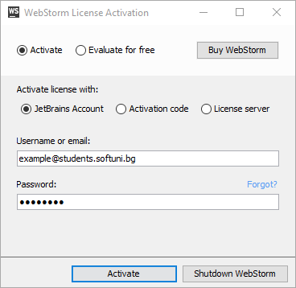So here is the part where we should enter our information about license. The easiest way is just to choose the "**Evaluate for free**" option but since we are provided with student's email (that "**@students.softuni.bg**" thing) we could use that to create a **JetBrains** **account** with it and enter our credentials for it in the displayed form below:

**Note:** If you are inserting your email (like showed above) you should insert your **account's** **password** – not the **email's** one. If you don't have JetBrains account create it [here](https://account.jetbrains.com/login) using the **email** that SoftUni provided for you.

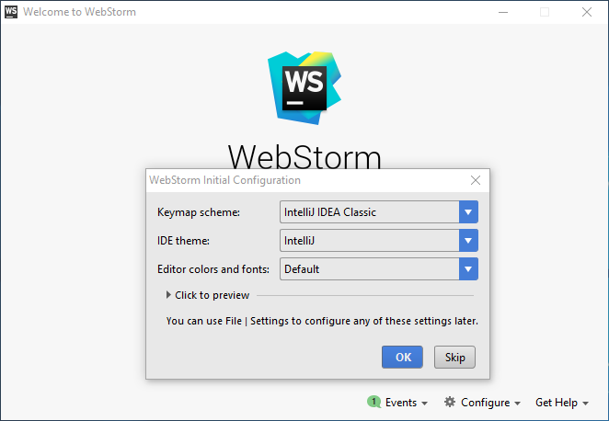One more thing – choose the themes you want (you can change them later):

It's **done**! Now you can use **WebStorm**! :)

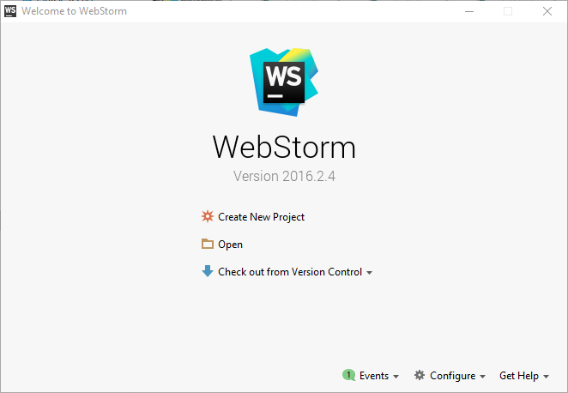For any other initial setup (like themes and so on) you can see this guide: [here](https://www.jetbrains.com/help/webstorm/2016.2/quick-start-guide.html).

## Резултат с изображение за webstormIntelliJ with Plugin

As said above WebStorm is close to PhpStorm and IntelliJ. This is not only visually but when it comes to functionality too. Therefore you can create Javascript projects easily using IntelliJ for an example. In order to that in IntelliJ you have to download this plugin.

**Pros**:

* Has **all** the **pros** of the WebStorm IDE.
* “With one bullet – two rabbits” – ”With one IDE – two languages”
* Has a **community** edition(free), unfortunately can build only Java/Android projects.

**Cons**:

* Requires license for creating more “advanced/complex” applications.
* Requires [plugin](https://plugins.jetbrains.com/plugin/6098) for Node.js development (any other different development also may require plugin).
* Plugin updates are **later** than the platform ones – this means that when a new **update** is patched for that platform you use - you have to **wait more** time for this changes to be implemented in the plugin.

You can **download** the IDE from this link: [click](https://www.jetbrains.com/idea/download/#section=windows). Make sure you download the **Ultimate** edition.

**Installation** is pretty much the **same** like **WebStorm**. After installation is done you can safely install Node.js plugin or look at the link below where is given information about how to install Node.js and how to install plugins overall:

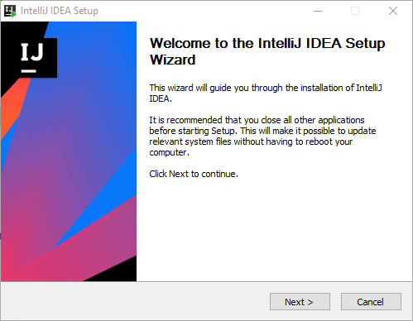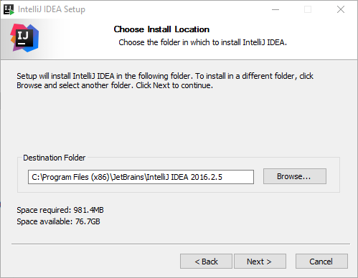

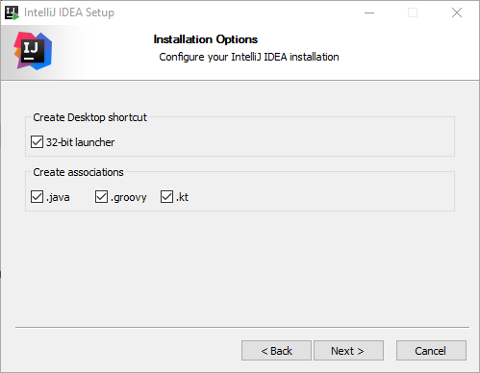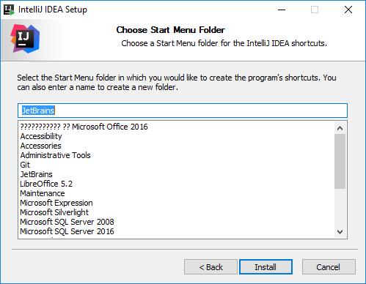

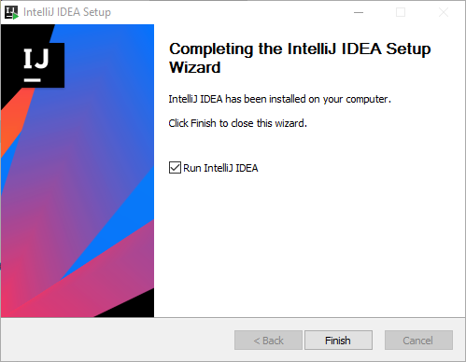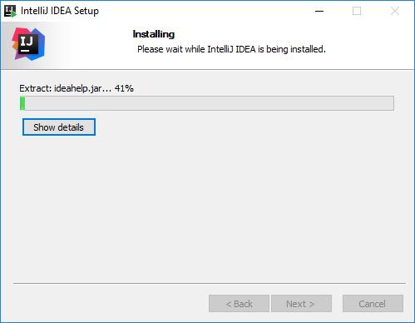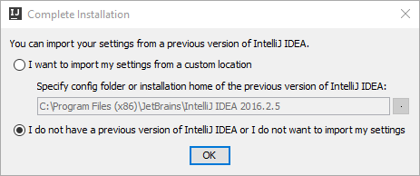

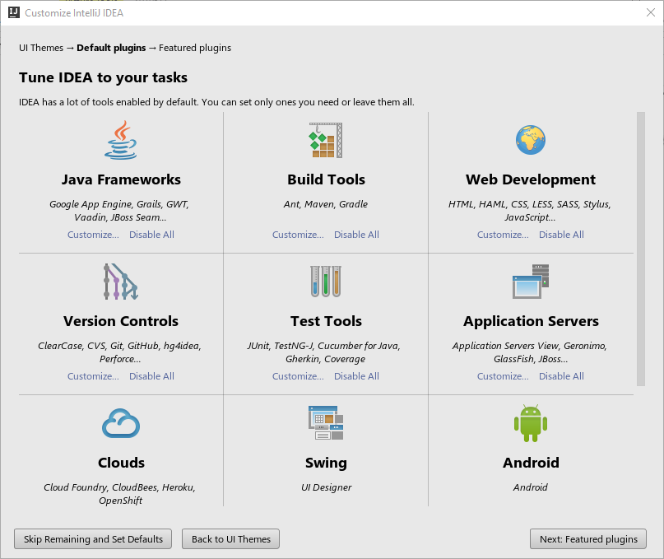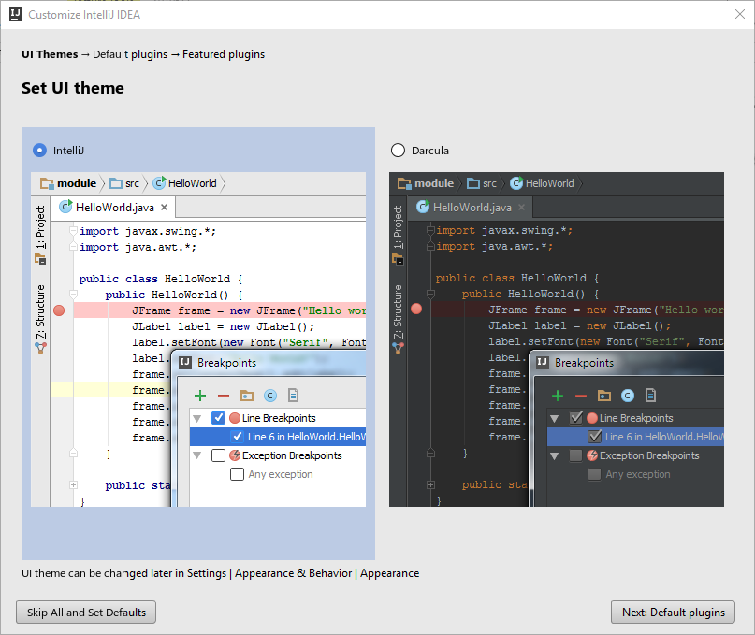Choose whatever theme you like. :) Move into the "**Default plugins**".

Here you can setup anything you would like to use but since we are starters we can just click "**Featured plugins**".

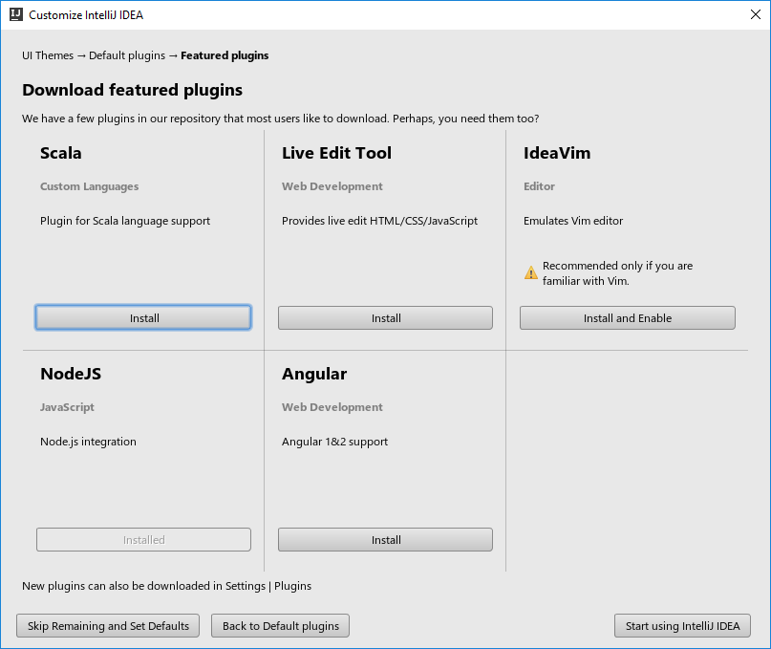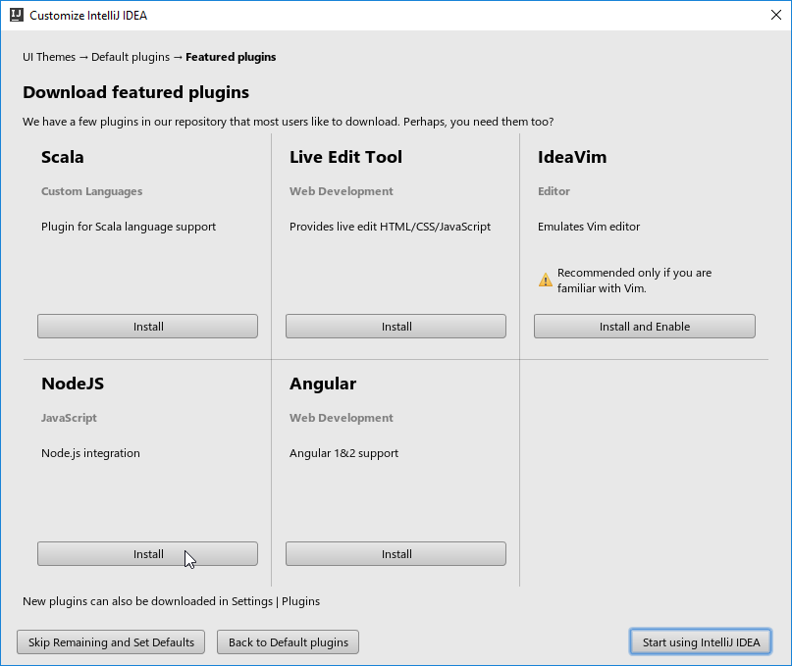Here we can install the **Node.js** plugin or do that [later](https://www.jetbrains.com/help/idea/2016.2/node-js.html).

After the install is complete you can "**Start using IntelliJ IDEA**"**.**

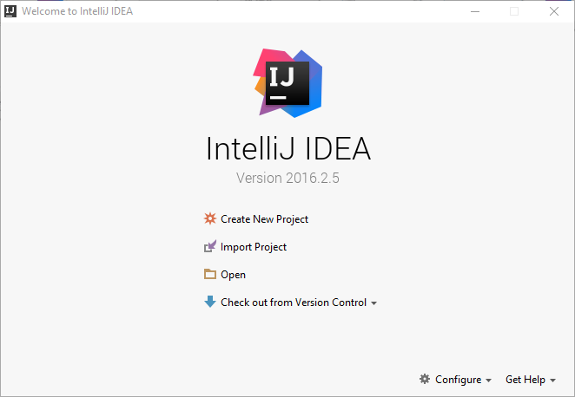For any Javascript/Node.js development you can read these articles: [Javascript](https://www.jetbrains.com/help/idea/2016.2/javascript-specific-guidelines.html) and [Node.js](https://www.jetbrains.com/help/idea/2016.2/node-js.html).

# Резултат с изображение за node jsNode

In order to create Javascript implemented server you have to use **Node.js**. Node.js is a platform made in **Javascript**, which is later on **translated** to **C++**, therefore server is fast and alongside using **Lubiv** I/O library we can work with the **file** system. More information about Node.js you can find in: [Wikipedia](https://en.wikipedia.org/wiki/Node.js), [StackOverflow](http://stackoverflow.com/questions/1884724/what-is-node-js) or you can check this [tutorial](https://www.tutorialspoint.com/nodejs/nodejs_introduction.htm).

## Download

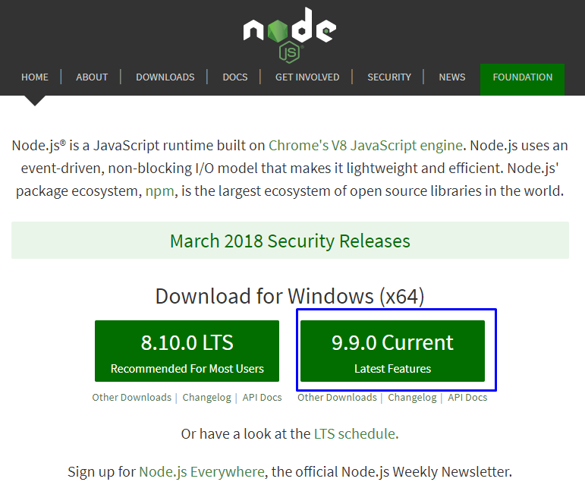

You can download Node.js from their official [site](https://nodejs.org/en/download/current/). There will be **two** options which version of Node to install - we **recommend** to be the “**Latest Features**” one in order to test and play with **newest** and coolest features in the Node.js world. However if you **want** to create more “advanced” and **heavy reliable** website for bigger purposes (more than **blog** functionallity) you better choose “Recommended**”** one:

## Installation

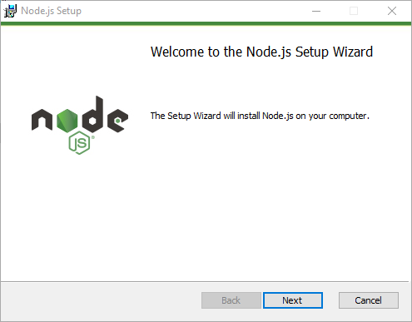Installation of Node for Windows users is simple (**Next** -> **Next** -> …)



